04. Hashing

- Introduction

The hash table is an array of a fixed size H_SIZE. The keys are mapped into the numbers in the range 0 to H_SIZE–1. The mapping function is also called hash function. A good hash function should satisfy the following requirements.
- It is simple to compute.
- It can distribute the keys evenly among the cells.

When two keys hash to the same value, we say that a collision occurs. A good hash function should minimize the number of collisions. Generally, H_SIZE is a prime number in order to minimize the collisions.

int hash(const string &key, int tableSize)
{
int hashVal = 0;

for (int i = 0; i < key.length(); i++)
{
hashVal += key[i];
}

return hashVal % tableSize;
}

The following show another hash function that is used for strings that have at least three characters.

int hash(const string &key, int tableSize)
{
return (key[0] + 27 * key[1] + 729 * key[2]) % tableSize;
}

- Separate Chaining

Separate chaining keeps a list of all elements that hash to the same value. If the size of the hash table is not large enough, there may be many keys map into the same value, which makes the lists very long. In this case, a binary search tree or another hash function can be used to make the operation faster. The cost for a search is a constant time that is required to evaluate the hash function plus the time to traverse the list.

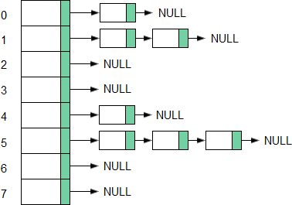

The load factor of a hash table is the ratio of the number of elements in the hash table to the table size. For separate chaining, the load factor should be close to 1.

- Open Addressing

In open addressing, when a collision occurs, the cells c₀(x), c₁(x), c₂(x), … are tried until an empty cell is found, where c_{i}(x) = (hash(x) + f(i)) mod H_SIZE, with f(0) = 0. The f function is called collision function. Because all the data go inside the table, a bigger table is needed than for separate chaining hashing. Generally, for open addressing, the load factor should be below 0.5.

The following shows three common collision resolution strategies.
- Linear probing. The f function is a linear function of i, typically f(i) = i.
- Quadratic probing. The f function is quadratic, typically f(i) = i². For quadratic probing, if the table size is prime, then a new element can always be inserted if the table is at least half empty. If the table is more than half full, the insertion could fail.
- Double hashing. It uses a second hash function to find an empty cell, f(i) = i * hash₂(x).

Open addressing has the following limitations.
- The collision function must make sure that all the cells can be probed. Otherwise, a new element to be inserted may not be able to find an available space even if the list is not full.
- Standard deletion cannot be performed in a probing hash table, because the following elements may be missed if an element is deleted. It requires lazy deletion.
- Blocks of occupied cells may occur. This is known as clustering.

- Rehashing

If the table gets too full, the running time for the operations will start taking too long and insertions might fail for open addressing hashing with quadratic resolution. Rehashing is a solution which is to build a new table twice as big as the old table, and copy the data from the old table to the new table using the new hash function. Rehashing may occur in the following conditions with quadratic probing.
- The table is half full.
- An insertion fails.
- The table reaches a certain load factor.

Hashing doesn't require that the keys are sorted in order. Using a hash table, it is impossible to find the minimum element or a string unless the exact string is known.

